MULTI-LANGUAGE TOOL EDITOR WINDOW

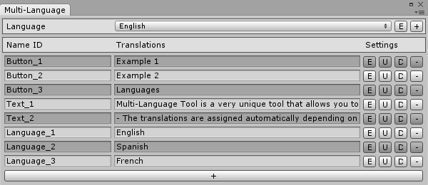
Language: displays the different languages you have added. Selecting one of them you can write different translations for a Name ID.
E: shows a text field where you can modify the language name or even delete the language.
+: adds a new language.
Name ID: is the name you're going to use to assign the different translations.
Translations: here you can write different translation for each of the languages you have added.
Select a language on the "language" enum popup to modify its translations.
Settings:
E: extends the translation text field.
U: moves up the whole line.
D: moves down the whole line.
-: deletes the whole line.
+: adds a new line with a name ID and translations.

LANGUAGE MANAGER SCRIPT

The Language Manager script is required in all scenes if you want to use the Multi-Language Tool translation system, you can find a prefab of it in the Prefabs folder. This script is going to take care of storing the current language (in runtime) and managing the different translations for the Name IDs.

The Language Manger script is the core of the tool because it is the script the user can access when changing the current language or storing a translation on a string variable is needed. Don't forget that in order to access its methods is necesary a reference prevoiously.

Here you can see the different methods the script contains:

-GetLanguage(); Returns the current laguage.
-SetLanguage(string name); Changes the current language.
-SetLanguage(int index); Changes the current language.
-GetTranslation(string nameID); Returns a translation asociated to a Name ID depending on the
current language.
HOW TO USE MULTI-LANGUAGE TOOL

You have two ways of using the tool: with the new UI Canvas or with the old GUI system. Using it with the new UI Canvas may be easier if you don't know how to code, but even if you are a great programmer you may prefer to use this option beacause the user interface graphical result is way better.

UI Canvas:

All changes are going to be applied to a UI Text component, this is the reason why the Canvas Translator script (inlcuded inside the Multi-Language Tool menu) inserts a UI Text component when you add it.
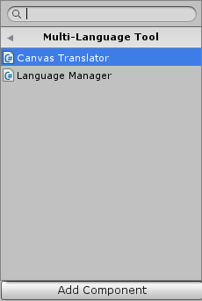
Once you have implemented the Canvas Translator script you will have to write the Name ID it is going to match, this way the text form the UI Text script will be automatically assigned, depending on the current language, with the translations you set up in the Multi-Language Tool editor window.

In order to make a button that changes the game language you have to drag the Language Manager script to the On Click () method inside the button script, then call the SetLanguage() method and finally write the language you want to move to (the language must have been added in the Multi-Language Tool editor window before).

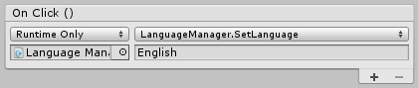
Make sure that the name you write matches perfectly with one of the languages you have set up previously, otherwise nothing will happen when you press the button. It is important to know that the LanguageManger script only works during runtime.
GUI System:

Using the GUI system requieres a little bit of coding. Here I'm going to show you how to access the simple Multi-Language Tool API.

First of all what you need to do is to get a reference of the Language Manger script which should have been added to your scene previously.

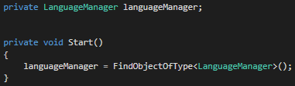
Here I'm going to show you how to create a button with a translated text depending on the current game language.

In order to store a translation in a string you just need to call the LanguageManager.GetTranslation() method and then pass the Name ID. Depending of your current language you will get a different translation (the one you have set up for that language in the Multi-Language Tool editor window).

LanguageManager.GetTranslation("Button_1");

Now you know how to translate the button text, but how do you change the language of you game so you can see the different translations?

The Language Manager script takes care of managing the game language and then assings the translations as you have seen before but if what you want is to change the current language you would have to call the LanguageManager.SetLanguage() method and then pass the name of the langauge you want to move to, or its index.

LanguageManager.SetLanguage("English");

Demos:

Everything that has been explained here is part of the demos that the project includes (the pictures are part fo them).

In the projet you can find two demos according with the two posibilities of creating the user interface of your game. They are located in the Demos folder inside the project.

-New UI Canvas: inlcudes a simple user interface with buttons and text areas.
-Old GUI System: inlcludes a complete Menu Manger script that displays a bunch of buttons.
HOW THE DATA IS STORED

Multi-Languge Tool stores the data inside of an XML file called "Languages" which can be found in the resources folder of your project. Storing the data to an XML file allows a faster load and an easier way to save it. This also creates a clear file that is very simple to read and understand.

